University of Missouri

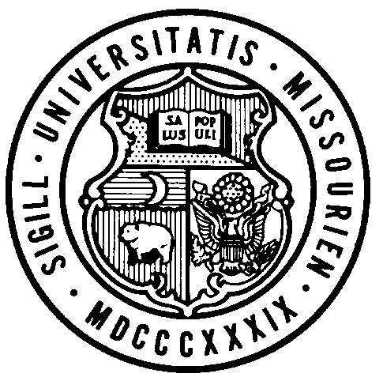
Board of Curators

Special Meeting

Tuesday, August 10, 2021
8:15 A.M.

Originating:
From remote locations via Zoom and/or conference telephone.

Zoom Webinar Link: https://umsystem.zoom.us/j/99197394966
Webinar ID: 99197394966

Public Session Dial-In Number: +13017158592,,99197394966#

AGENDA

PUBLIC SESSION – 8:15 A.M.

Call to Order – Chair Chatman

Roll Call of the Board of Curators

General Business

Action
- Resolution for Executive Session, Special Board of Curators Meeting, August 10, 2021

8:20 A.M. BOARD OF CURATORS SPECIAL MEETING-EXECUTIVE SESSION (time is approximate)
Via Zoom

The Board of Curators will hold an executive session of the August 10, 2021 special meeting, pursuant to Sections 610.021(1), 610.021(3), 610.021(12) and 610.021(13) RSMo, for consideration of certain confidential or privileged communications with University Counsel, contract and personnel items, all as authorized by law and upon approval by resolution of the Board of Curators.

